**Screenshots of 2.3 exercises**

**INSTALLED nvm via command prompt**

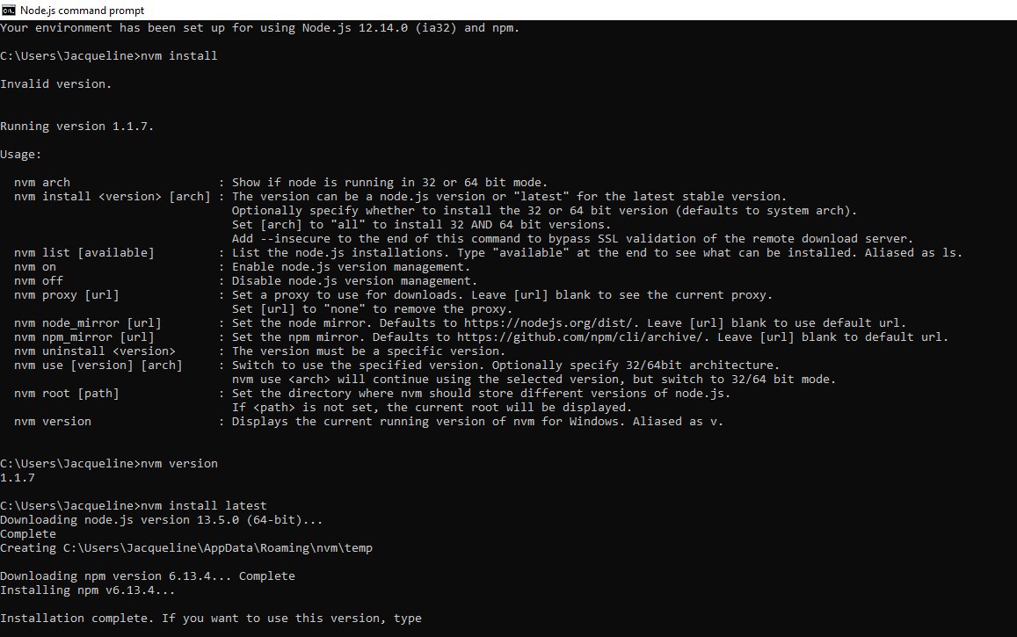

**Node.js installed via nvm**

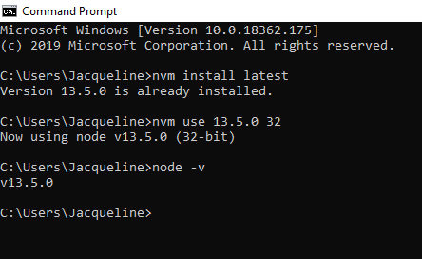

**npm version checked and updated**

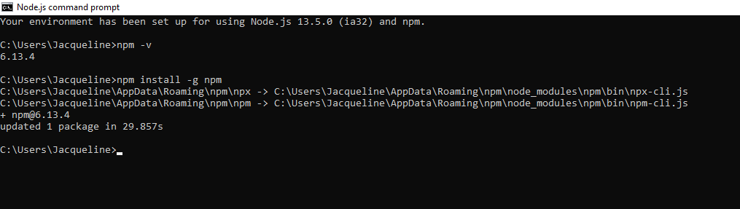

**Created index.js, installed packages/express/body parser via git bash**

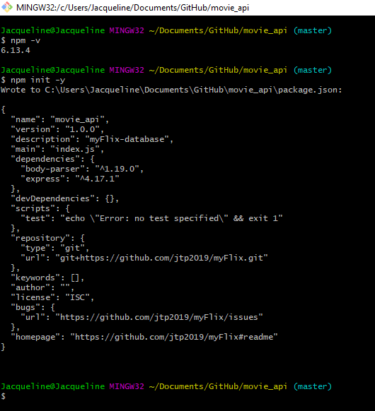

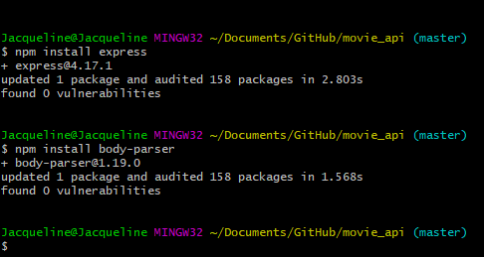

**Push all changes to git repository**

